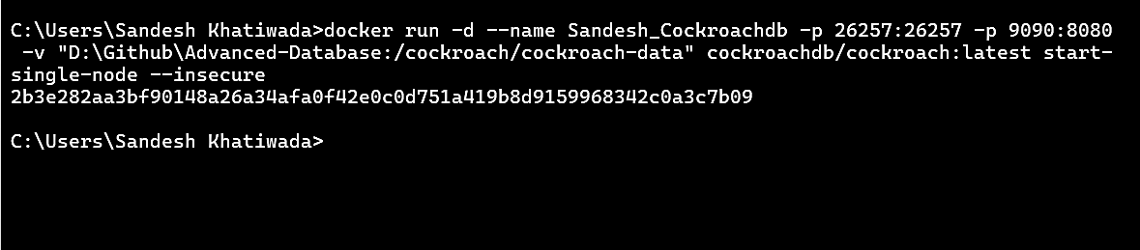
Localhost:9090
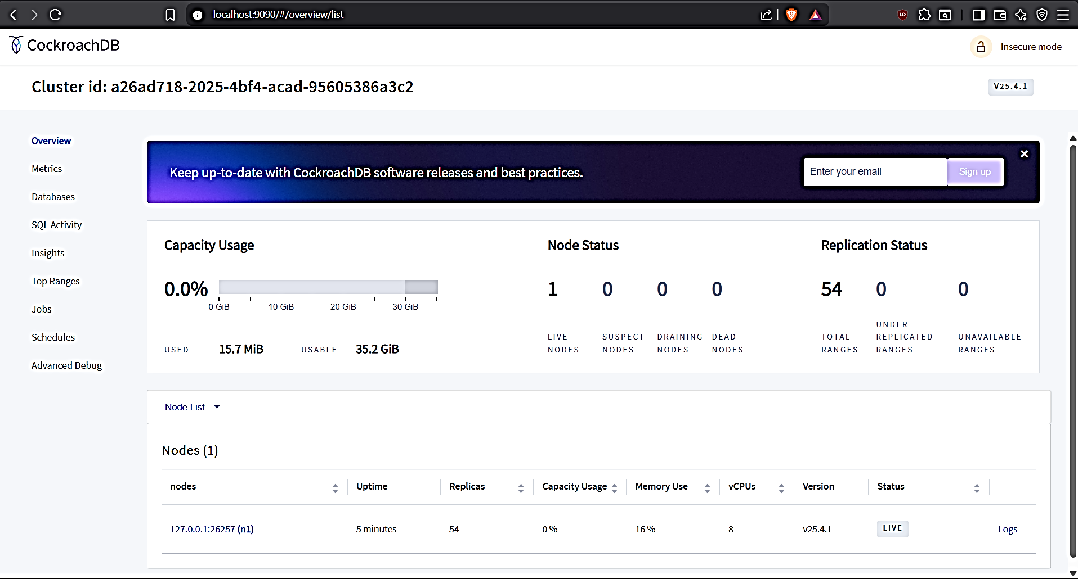

SQL Shell:
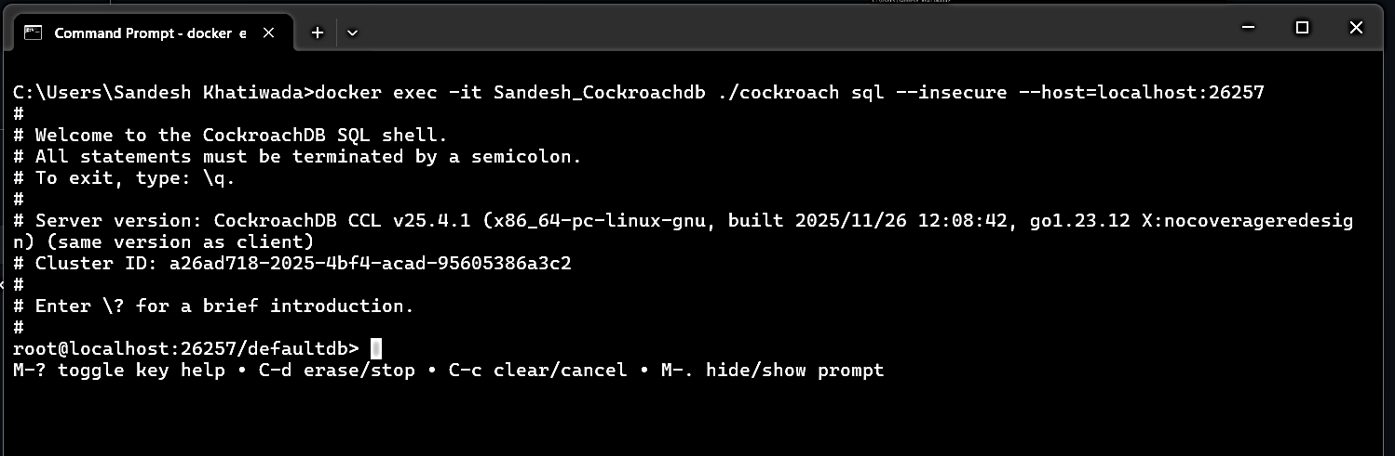

Create a database:
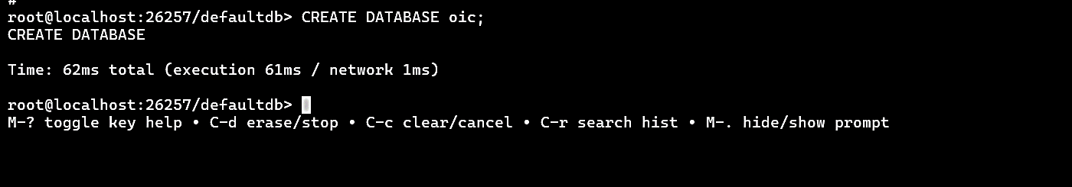
Use oic :
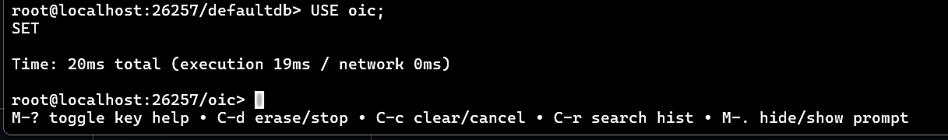
Table creation:
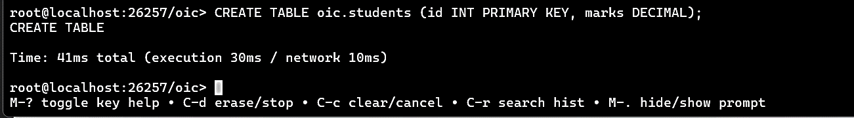
View table:
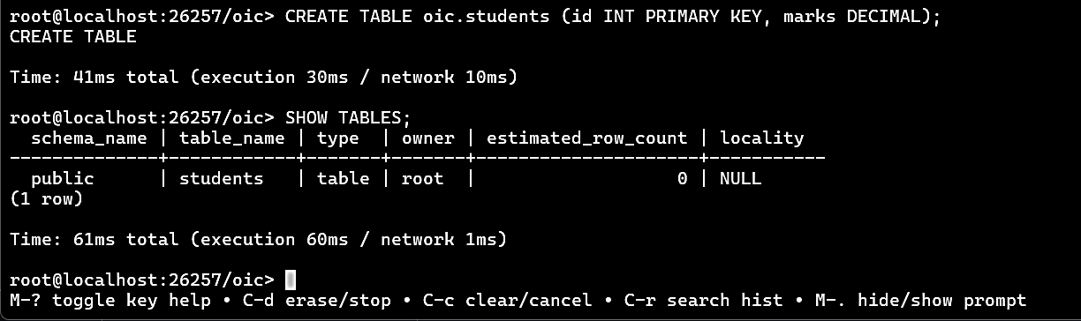
Insert and view database:
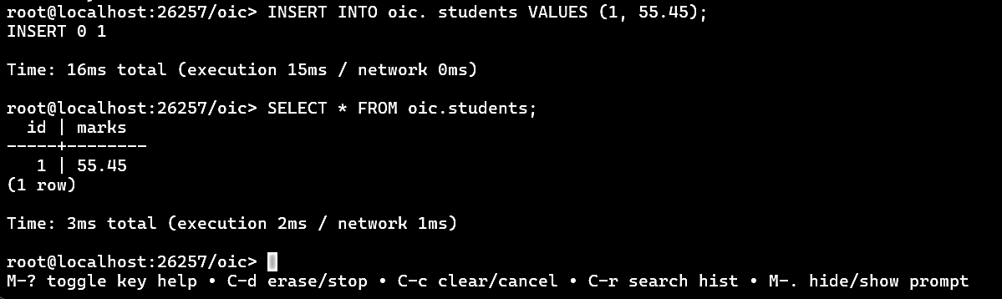

PART 2: Scale to 3-Node Cluster
Exit SQL shell
Type: \q
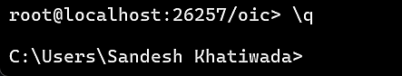

Stop single node container:
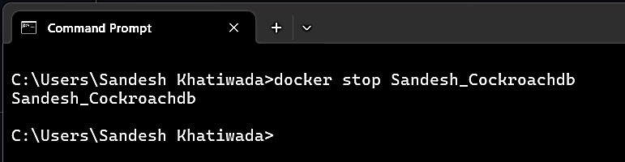

Remove single-node container:
docker rm Sandesh_Cockroachdb
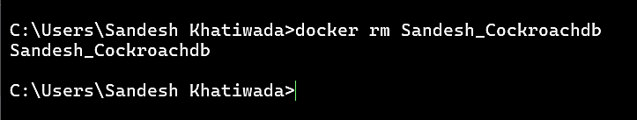

Create docker network for 3-node cluster:
docker network create cockroach-net
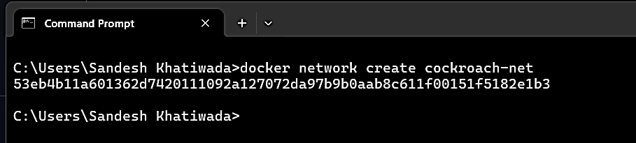

Start node1:
docker run -d --name node1 --hostname node1 --net cockroach-net -p 26257:26257 -p 9090:8080 -v “D:\Github\Advanced-Database\node1:/cockroach/cockroach-data” cockroachdb/cockroach:latest start --insecure --advertise-addr=node1:26257 --http-addr=0.0.0.0:8080 --join=node1:26257,node2:26257,node3:26257
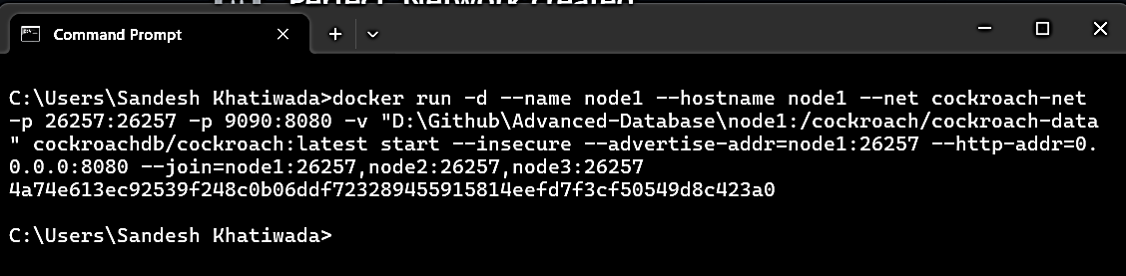

Start node 2:
docker run -d --name node2 --hostname node2 --net cockroach-net -p 26258:26257 -p 9091:8080 -v "D:\Github\Advanced-Database\node2:/cockroach/cockroach-data" cockroachdb/cockroach:latest start --insecure --advertise-addr=node2:26257 --http-addr=0.0.0.0:8080 --join=node1:26257,node2:26257,node3:26257
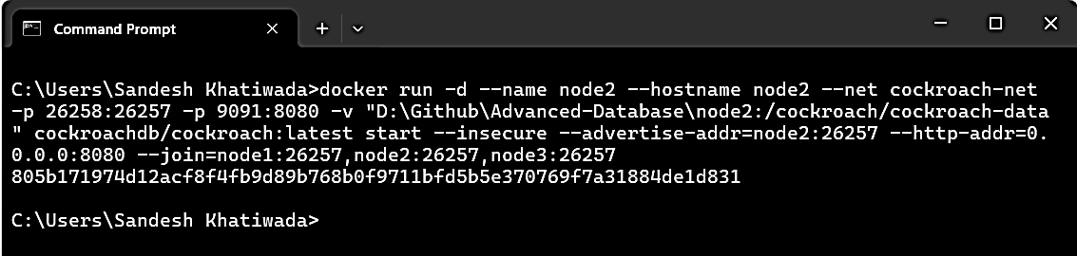
Start node3:
docker run -d --name node3 --hostname node3 --net cockroach-net -p 26259:26257 -p 9092:8080 -v "D:\Github\Advanced-Database\node3:/cockroach/cockroach-data" cockroachdb/cockroach:latest start --insecure --advertise-addr=node3:26257 --http-addr=0.0.0.0:8080 --join=node1:26257,node2:26257,node3:26257
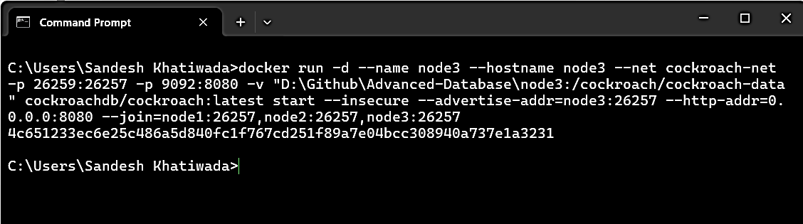

Initialize the server:
docker exec -it node1 ./cockroach init –insecure
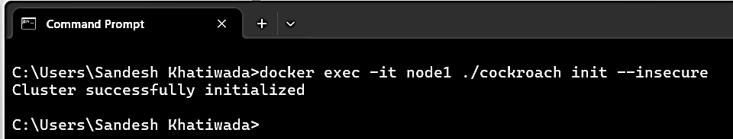

Checking if cluster is working:
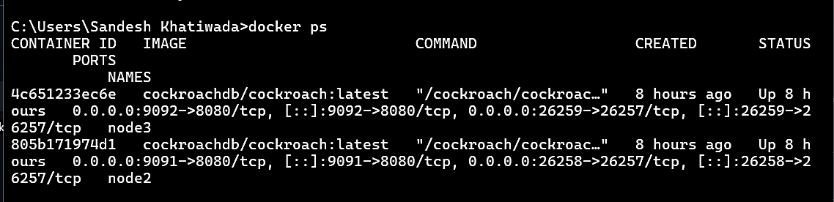
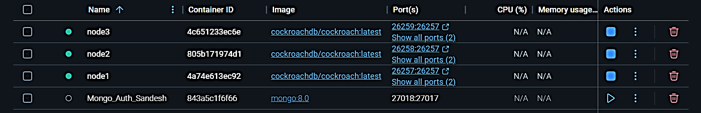

To confirm all 3 nodes are up and have same cluster:
Node 1:
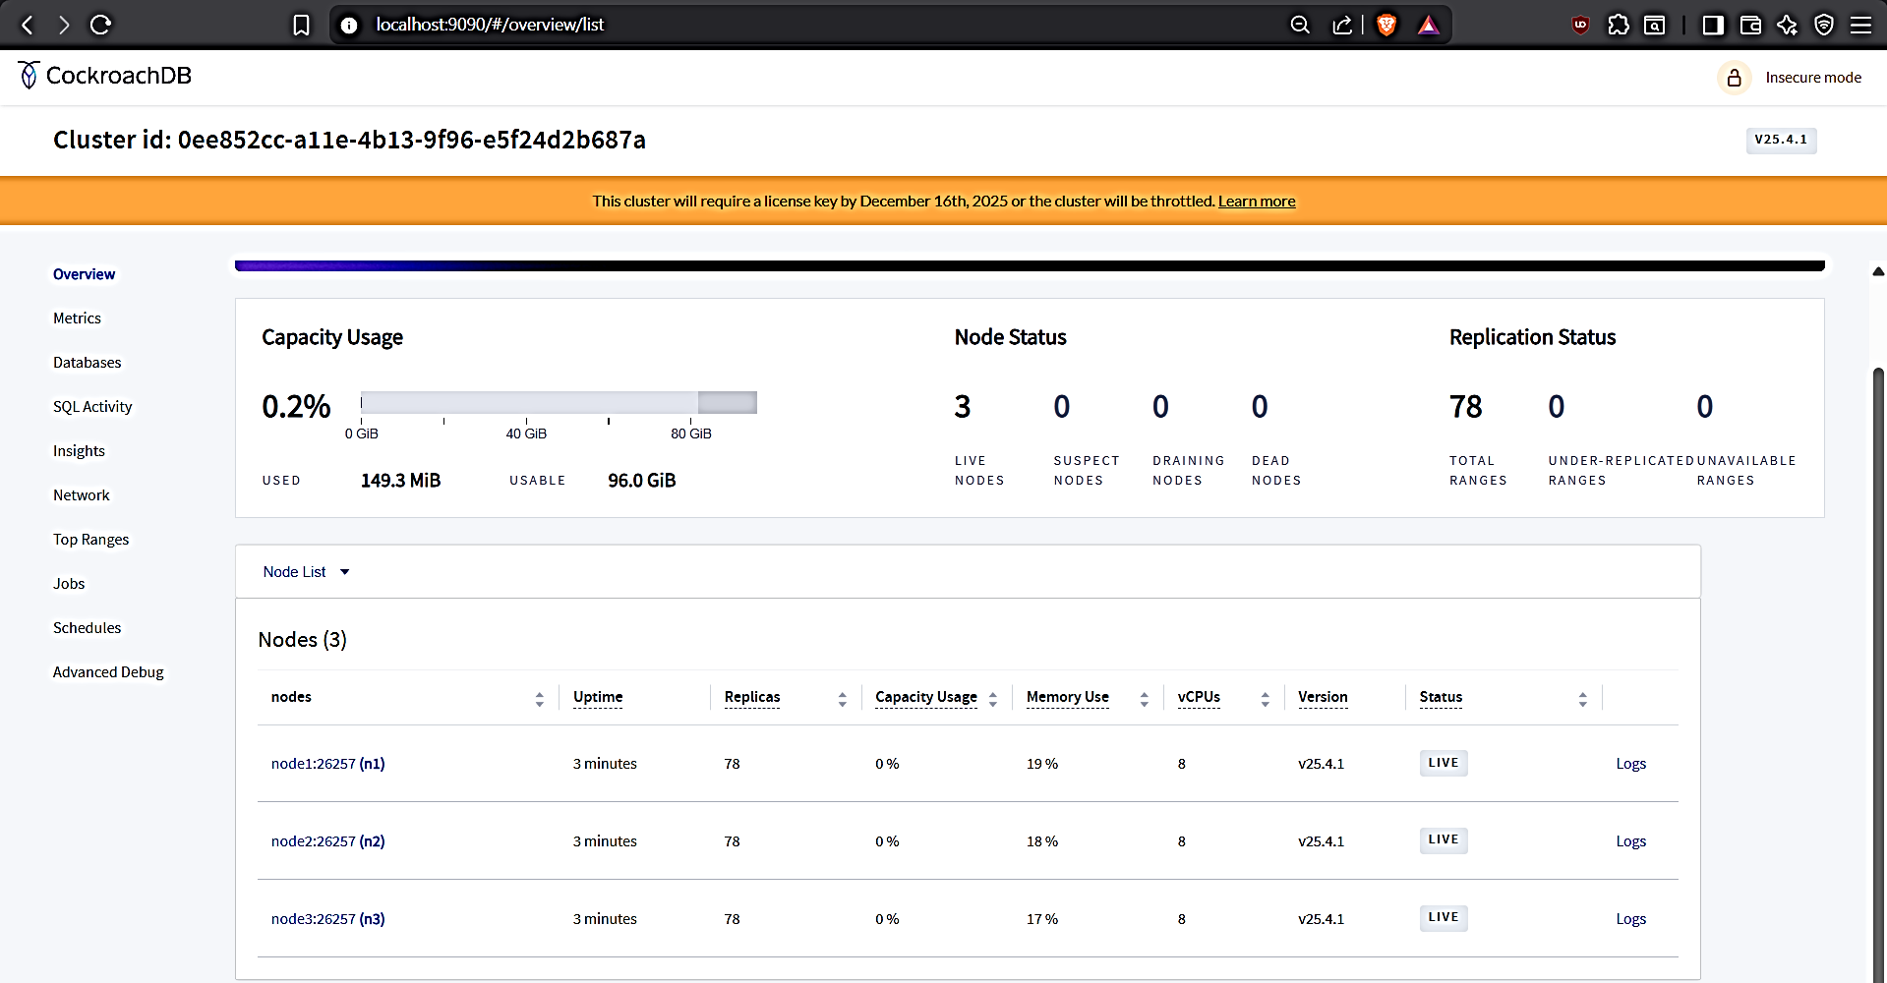

Node 2:
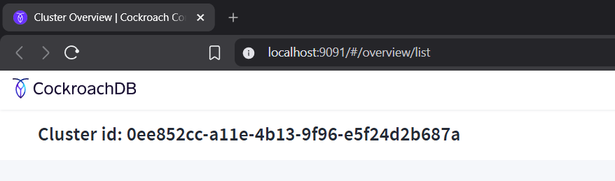

Node 3:
